# SALT SSL login configuration

Edit the Bindings for the Website:

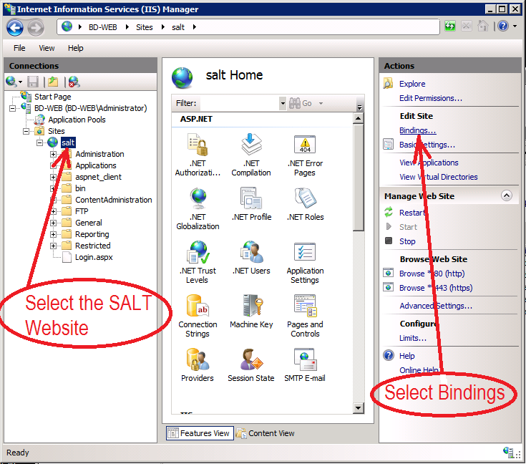

Select https and edit:

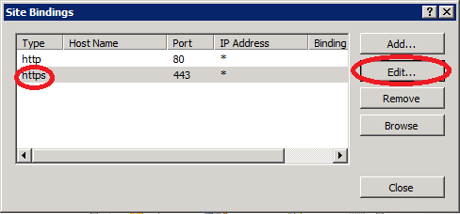

(if https is not available check if your certificates are registered correctly)

Choose the correct certificate for this Website, press OK then close

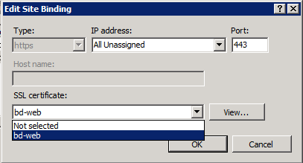

To navigate to the login.aspx file select Content View:

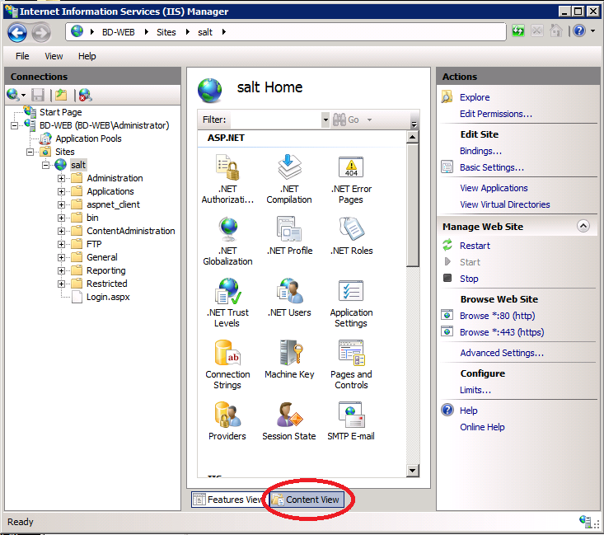

Select the file Login.aspx then “Switch to Features View”:

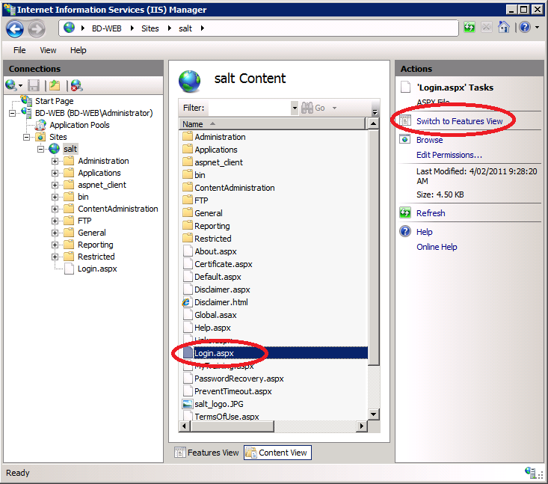

Double Click on SSL Settings:

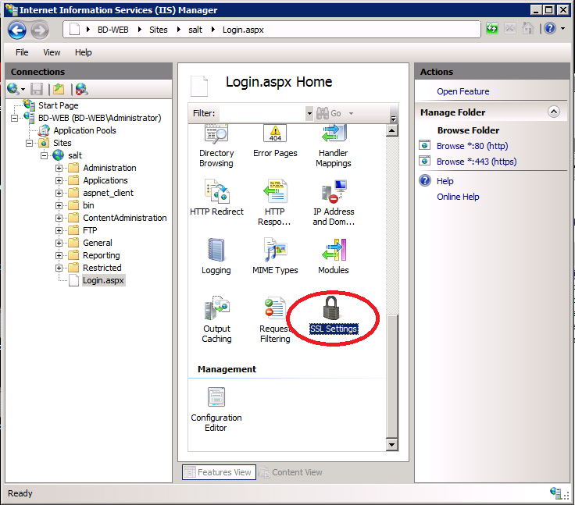

Select “Require SSL” then Apply

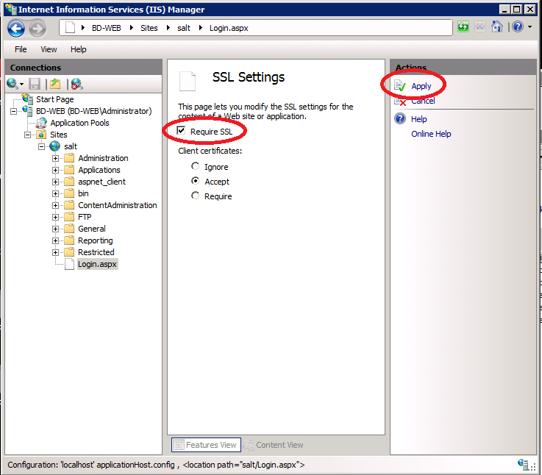

Select the SALT Website then Authentication then “Forms Authentication” and choose “Edit”

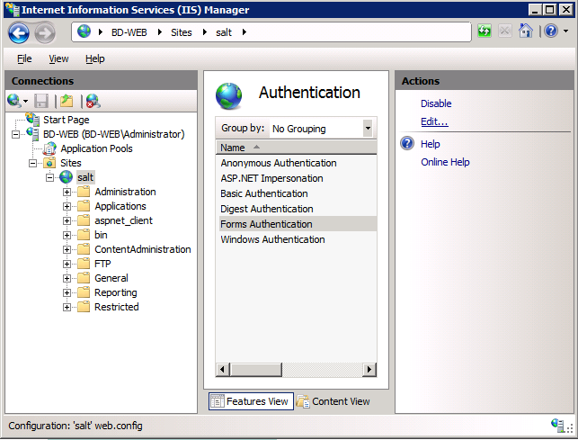

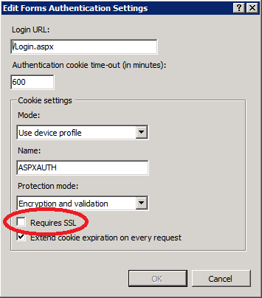

Ensure that “Requires SSL” has **NOT** been selected

Edit the Web.config file, the appSettings section contains a key for EnableSSL , set it to true:

<add key="EnableSSL" value="true"/>

</appSettings>

Select the SALT Website again, choose Restart then Browse *:443 (https)

